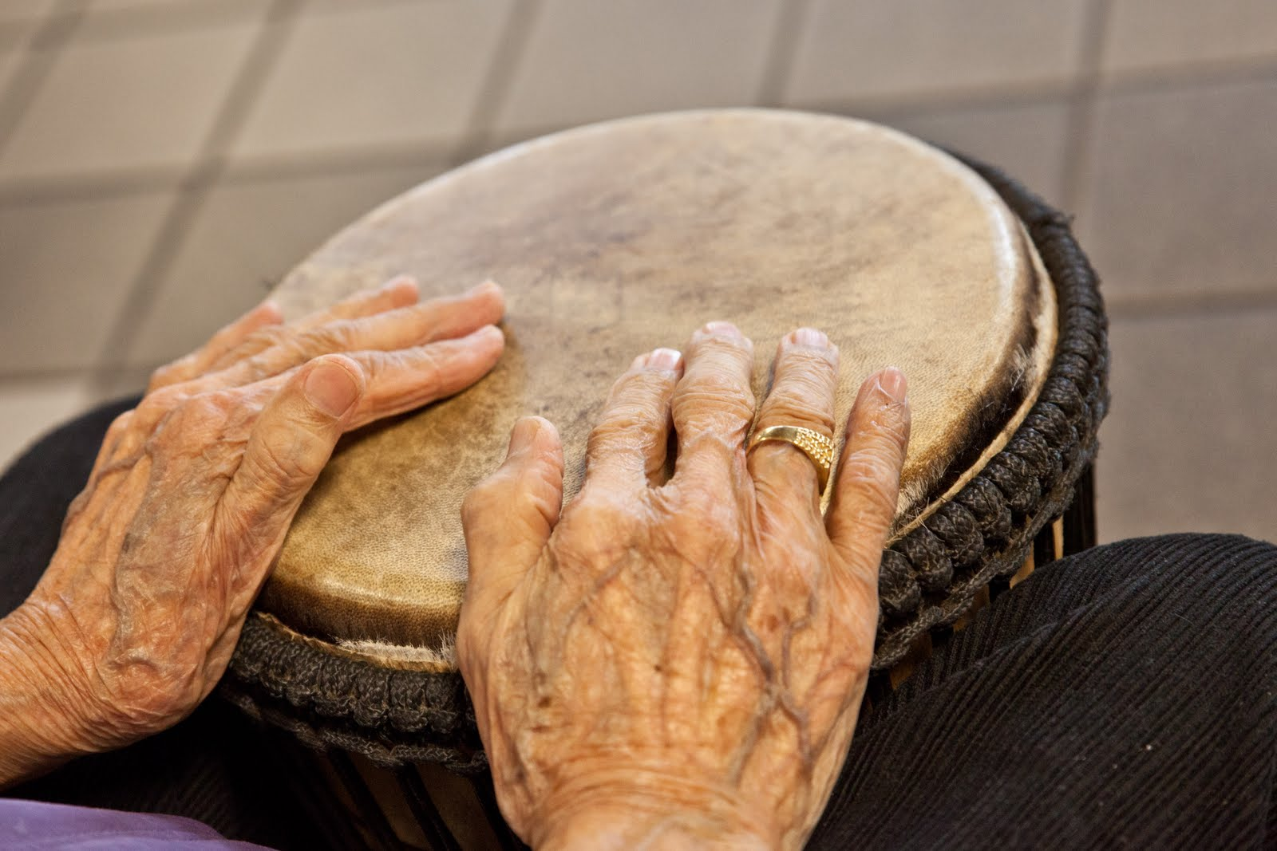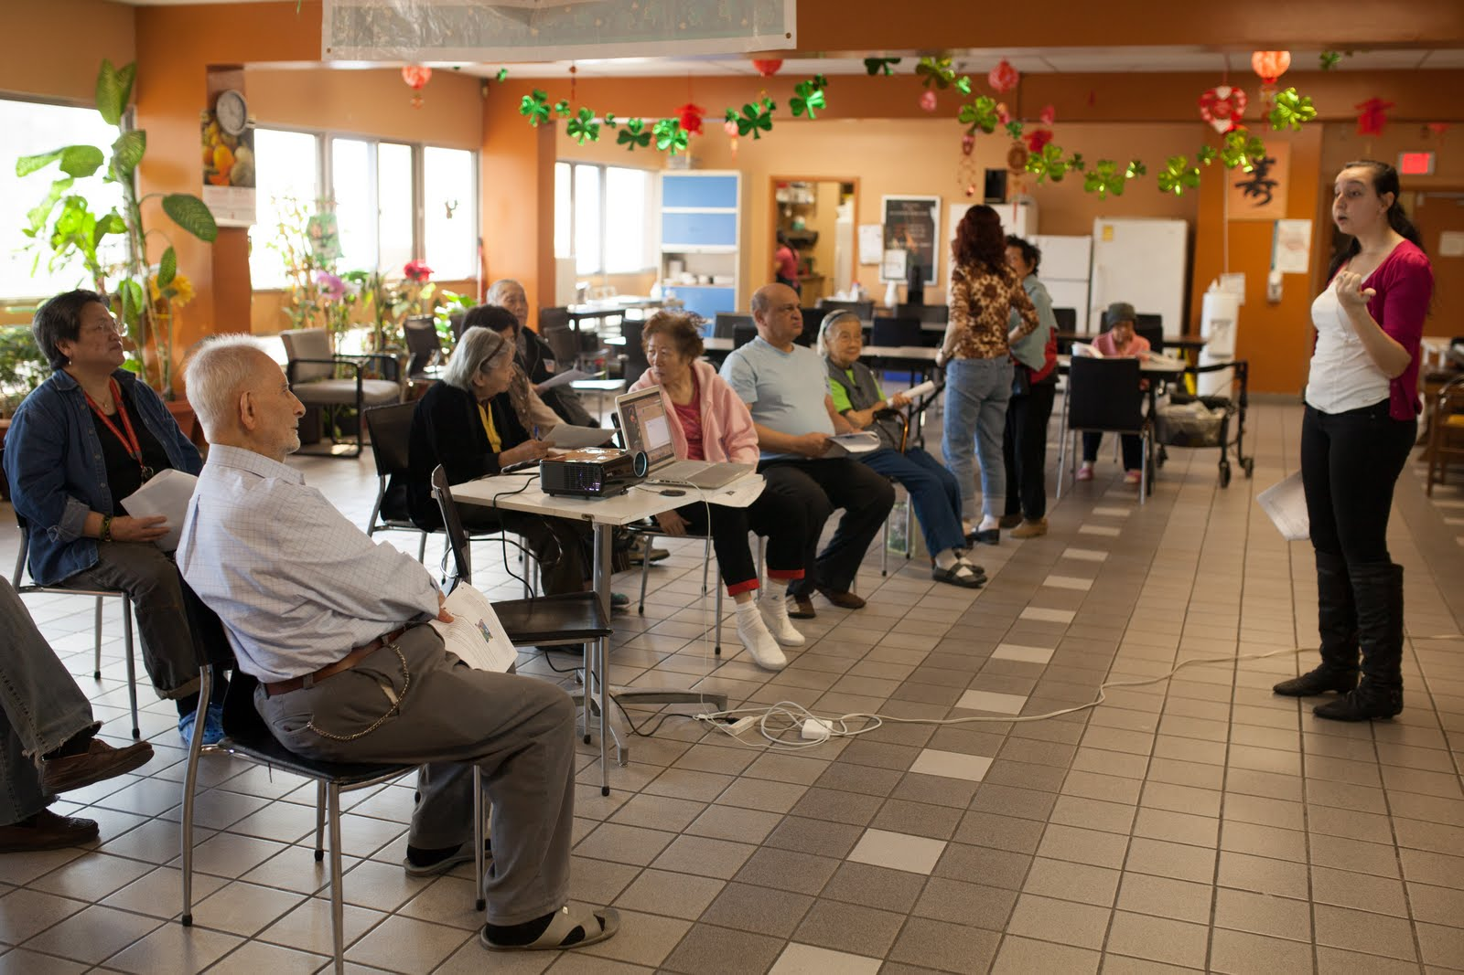

**Healthy Together**

***Wellness Workshops for Older Adults***

***Funded by New Horizons***

cid:image001.png@01CD2C3C.6E4ECB90



**insert LOFT and Toronto Housing LOGOS**

**“HealthyTogether” Wellness Toolkit**

**Facilitators Guide**

**Written April 2013**

FOR THE FACILITATOR:

The “healthy living” toolkit was originally developed through funding from New Horizons to improve the health and wellness of marginalized older adults through regular exercise classes and 7 wellness workshops. The program was piloted in downtown Toronto, Canada, from September to March 2013 and the workshop materials developed for use by any charity or community organization.

The workshop topics were decided by surveying the residents of a large subsided housing community. A copy of this survey can be found in the evaluation guide.

Community partners such as the police, a local pharmacist and a drumming group were asked to write and present workshops as well as presentations from COPA (Community Outreach Programs in Addiction), Toronto Housing and Vintage Fitness.

We created presentation frameworks for each of the workshop to give to external presenters. These frameworks may change to better suit the needs of the population that you are planning to work with.

Presentation Framework:

Module One: “ Healthy Living”

Presented By: Local community health or addiction specialist charity

|  |  |  |  |
| --- | --- | --- | --- |
|  | What Older Adults should know about healthy living | What Older Adults can do to stay healthy | Why? What benefits will Older Adults notice? |
| In General | Healthy eating, practices, relationships and active lifestyle as part of healthy living and strategies to improve them. | REAP the BENEFITS model. Try to maintain healthy living through:  **R**elationships  **E**ating healthy  **A**ctivities  **P**ractices | Making healthier lifestyle choices can improve one’s overall quality of life including physical, mental and emotional health. It is important for older adults to take care of their physical and mental health to prevent illness and manage chronic conditions. |
| Local Resources | Ideas and tips on accessing health promotion services | Talk to your health care professional | Opportunities to engage in the life of their community and develop natural support relationships. |

**Module Two: “Fall Prevention”**

Presented By: Geriatric health and wellness professional (specialized personal trainer, physiotherapist, recreational therapist)

|  |  |  |  |
| --- | --- | --- | --- |
|  | What Older Adults should know about fall prevention | What Older Adults can do to stay safe from falls? | Why? What benefits will Older Adults notice? |
| In General | How common falls are amongst older adults  That falls are preventable  How to get up if they do have a fall | Demonstrate, practice and give exercise handbook of the best fall prevention exercise and tips | Less prone to falls  Feel more stable  Legs should feel stronger  How preventing falls will better their quality of life |
| Local Resources | Fall prevention and balance based (i.e. Tai Chi and Yoga) community classes | Provide links to other local fall prevention resources  erin@vintagefitness.ca | Fall prevention presentation  www.vintagefitness.ca |

**Module Three: Safety tips on medications**

Presented by: Local Pharmacist

|  |  |  |  |
| --- | --- | --- | --- |
|  | What Older Adults should know about taking medications safely? | What Older Adults can do | Why? What benefits will Older Adults notice? |
| In General | What is the role of a pharmacist?  Review the most common mistakes older adults make when taking medications  Go through the ground rules about safe medicine practices such as storing medicine  Review the difference between generic and branded prescriptions  Review concept of medicines interacting with other prescription medicines or other non  Traditional medicine (i.e. herbal teas) | For example:  Check expiry dates on medications  Don’t mix medications  Book a pharmacist consultation  Don’t take medications with alcohol  Try different medicine packages such as pre-populated blister packs and easier to open lids | A better understanding of the services that their local pharmacist offers.  A chance to start a relationship with their local pharmacist |
| Local Resources | List local pharmacy with contact information |  | Question and Answer Video with a pharmacist  *Insert link* |

**Module Four: Creative Arts- Therapeutic Drumming**

Presented By: A musical or artistic performing group

|  |  |  |  |
| --- | --- | --- | --- |
|  | What Older Adults should know about creative arts? | What can Older Adults can do to express their creativity? | Why? What benefits will Older Adults notice? |
| In General | Art is first and foremost about self-expression and seniors can use the to create something that they can call their own. Art can be enjoyed anytime and everywhere, whether it be outdoors or indoors, rain or snow, hot or cold. Research shows that art for seniors can lead to positive outcomes. A 2010 article in the Journal of Active Aging states that “artistic endeavours target the healthy parts of the brain – areas untouched by disease…” Other benefits include reduction of anxiety and depression, increased concentration, greater social interaction and improved attention spans. Another thing to remember is that art is simply fun! | Play music  Crafts  Painting  Needlework  Dance  Singing  Photography  Poetry  Creative writing  Story telling | Art can be enjoyed individually, but is also a great vehicle to bring people together. Art can be shared and creates a space of acceptance and encouragement. It also gives opportunity for seniors to show their strengths and talents, but also allows for growth and learning. Art can bring older adults out of isolation and help them to be active and integrated into the community. In addition to the previously mentioned benefits, there is also positive impact in dealing with symptoms of diseases, enhancing self-awareness as well as awareness of others. |
| Local Resources | Ripple Rhythm (ripplerhythm@gmail.com) |  |  |

**Module Five: Staying safe**

Presented by: Local community police officer

|  |  |
| --- | --- |
|  | What can older adults do to stay safe on the street?  *Resource: RCMP Seniors Guidebook for safety and security* |
| In General | **Safety on the Street**  If street crimes (purse snatching, robberies, assaults, etc.) are a problem in your neighbourhood and you have a fear of being victimized, there are ways in which you can reduce the risk of victimization and increase your sense of personal security.  **Prevention tips**   * Walk only in well-lit areas. * Do not burden yourself with packages and a bulky purse. * Never display large sums of money in public. * Go shopping in pairs or in a group. * Walk in the centre of the sidewalk, away from alleys and doorways. * If you suspect you are being followed, cross the street, go to the nearest home, service station or business and call the police. * Be aware of your surroundings and avoid areas that increase your chances of being assaulted.   Report problem areas to police. The police welcome the information and can also advise you of prevention methods |
| Local Resources | <http://www.rcmp-grc.gc.ca/pubs/ccaps-spcca/seniors-aines-eng.htm#Street>  For full safety guide in pdf format including elder abuse, and safety in your car http://www.rcmp-grc.gc.ca/pubs/ccaps-spcca/pdf/seniors-aines-eng.pdf |

**Module Six: Using technology to stay connected**

Presented By: Any technically savvy front line charity staff

|  |  |  |  |
| --- | --- | --- | --- |
|  | What Older Adults should know about using technology to stay connected? | What Older Adults can do to stay connected | Why? What benefits will Older Adults notice? |
| In General | to communicate with the important people in their lives and stay connected to the things that matter | Available technology, its safety tips and etiquette to help older adults to stay connected. | Decreased isolation- Increased sense of membership  Increased sense of independence  Keeping in touch  Emergency communication Technology can be used as a tool to promote and support relationship, friendship and identity building |
| Local Resources | Local libraries, community centres, drop-ins and senior services offer computer classes and/or internet/computer access. | Ask your local librarian, social worker, housing worker for virtual opportunities and education. | Technology can be used as a way to add convenience, explore and stay connected to the community. |

**Module Seven: Best strengthening exercises for older adults**

Presented By: Geriatric health and wellness professional (specialized personal trainer, physiotherapist, recreational therapist)

|  |  |  |  |
| --- | --- | --- | --- |
|  | What Older Adults should know about strengthening exercises | What Older Adults can do to practice strengthening exercises? | Why? What benefits will Older Adults notice? |
| In General | Ask the group if they know what strength training is.  Discuss Health Canada’s recommendations around strength training for older adults (2-4 times per week)  Review most important muscles in the body to strengthen for older adults and why | Demonstrate the best strengthening exercises including information about safety  Provide handout with pictures of the exercises | Better Posture  Reduce risk of Osteoporosis  Weight Management  Feel better  Prevent Falls  Perform activities of daily living with ease |
| Local Resources | Insert health Canada link to guide | Best strengthening exercises handbook  [www.vintagefitness.ca](http://www.vintagefitness.ca) | **What should I consider before starting a new exercise program**?  Listen to cues from your body such as dizziness or pain and stop or modify the exercise  -Do you have any medical conditions such as Diabetes? If so be sure to check your sugar  levels before starting exercise |

**Tips we learned running the program:**

1. Many of our workshops participants did not speak English. Discuss how the workshop materials can be translated and if interpretation is needed for the presentation. Most of the “healthy living” participant handouts are available online at www.vintagefitness.ca in mandarin. .
2. We provided structured inputs to our external presenters and briefed them a month before their workshop. We found that many external presenters have a standard presentation so leave enough time for a long question and answer session so that client needs are fully addressed.
3. A steering committee consisting of representitives from both the organizations involved in the project and participants in the program helped us quickly understand and respond to participant concerns. For example at the beginning of the program the music and movement in the exercise classes was too fast and needed to be slowed down a bit.
4. The survey asking partiipants which workshop topics they would like to hear about helped to need the program about their needs.
5. Something about the evaluation plan?

**Evaluation Guide**

There are three distinct components that were evaluated

**1 Level of participants’ physical fitness at the beginning and end of the program as measured by the seniors fitness test.**

|  |  |  |  |
| --- | --- | --- | --- |
| **Test** | **Chinese**  **Translation** |  | **Results** |
| **Chair Stand** |  | *# of stands in 30 seconds* |  |
| **Arm Curl** |  | *# of curls in 30 seconds* | Right  Left |
| **2min Step** |  | *# of times right knee lifts to level while marching in 2 minutes* |  |
| **Chair sit and reach** |  | *Reach to foot - measure hands from toes* | Left cm  Right cm |
| **Back scratch test** |  | *Distance between fingers*  *+ overlap*  *0 – meet*  *- not meet* | Right arm over: + - cm  Left arm over: +- cm |
| **8 foot get up and go** |  | *Time from seated to around object and back to seated (agility)* | seconds |

**2. General Feedback about both the exercise classes and each wellness workshop.**

Feedback about the program:

1. Why do you attend the program?
2. Have you noticed any improvements or changes in your strength or overall wellbeing?
3. How could we make the program better?

“Healthy Together” Workshop Evaluation Questionnaire

Thank you for attending this workshop. We need your feedback to help us know if the workshop was helpful to you/to make improvements. Your responses will remain anonymous. Please take a few moments to complete this questionnaire and return it to the workshop presenter.

1. Did you learn anything new in this workshop?
2. Will you change anything day to day because of what you learned?
3. How motivated are you to make the changes suggested in this workshop?
4. How likely are you to recommend a similar workshop to a friend?
5. In your own words what did you get out of this workshop today?

1. **Evaluation of the participants overall quality of life before and after the program using the World Health Organization Tool.**

**Name:**

**Date:**

**WHOQOL-BREF**

The following questions ask how you feel about your quality of life, health, or other areas of your life. I will read out each question to you, along with the response options. **Please choose the answer that appears most appropriate.** If you are unsure about which response to give to a question, the first response you think of is often the best one.

Please keep in mind your standards, hopes, pleasures and concerns. We ask that you think about your life **in the last four weeks**.

|  |  |  |  |  |  |  |
| --- | --- | --- | --- | --- | --- | --- |
|  |  | Very poor | Poor | Neither poor nor good | Good | Very good |
| 1. | How satisfied are you with your health? |  |  |  |  |  |

|  |  |  |  |  |  |  |
| --- | --- | --- | --- | --- | --- | --- |
|  |  | Very dissatisfied | Dissatisfied | Neither satisfied nor dissatisfied | Good | Very satisfied |
| 2. | To what extent do you feel that physical pain prevents you from doing what you need to do? |  |  |  |  |  |

|  |  |  |  |  |  |  |
| --- | --- | --- | --- | --- | --- | --- |
|  |  | Not at all | A little | A moderate amount | Very much | An extreme  amount |
| 3. | How much do you enjoy life? |  |  |  |  |  |

|  |  |  |  |  |  |  |
| --- | --- | --- | --- | --- | --- | --- |
|  |  | Not at all | A little | Moderately | Mostly | Completely |
| 4. | Do you have enough energy for everyday life? |  |  |  |  |  |

|  |  |  |  |  |  |  |
| --- | --- | --- | --- | --- | --- | --- |
|  |  | Not at all | A little | Moderately | Mostly | Completely |
| 5. | Do you have enough money to meet your needs? |  |  |  |  |  |

|  |  |  |  |  |  |  |
| --- | --- | --- | --- | --- | --- | --- |
|  |  | Not at all | A little | Moderately | Mostly | Completely |
| 6. | To what extent do you have the opportunity for leisure activities? |  |  |  |  |  |

|  |  |  |  |  |  |  |
| --- | --- | --- | --- | --- | --- | --- |
|  | How well are you able to get around? | Very poor | Poor | Neither poor nor good | Good | Very good |
| 7. |  |  |  |  |  |  |

|  |  |  |  |  |  |  |
| --- | --- | --- | --- | --- | --- | --- |
|  | How satisfied are you with your sleep? | Very poor | Poor | Neither poor nor good | Good | Very good |
| 8. |  |  |  |  |  |  |

|  |  |  |  |  |  |  |
| --- | --- | --- | --- | --- | --- | --- |
|  | How often do you have negative feelings such as blue mood, despair, anxiety, depression? | Very dissatisfied | Dissatisfied | Neither satisfied nor dissatisfied | Good | Very satisfied |
| 9. |  |  |  |  |  |  |

10. 'Tell us in your own words what this program does for you’